PUMPKN PIE TARTLETS 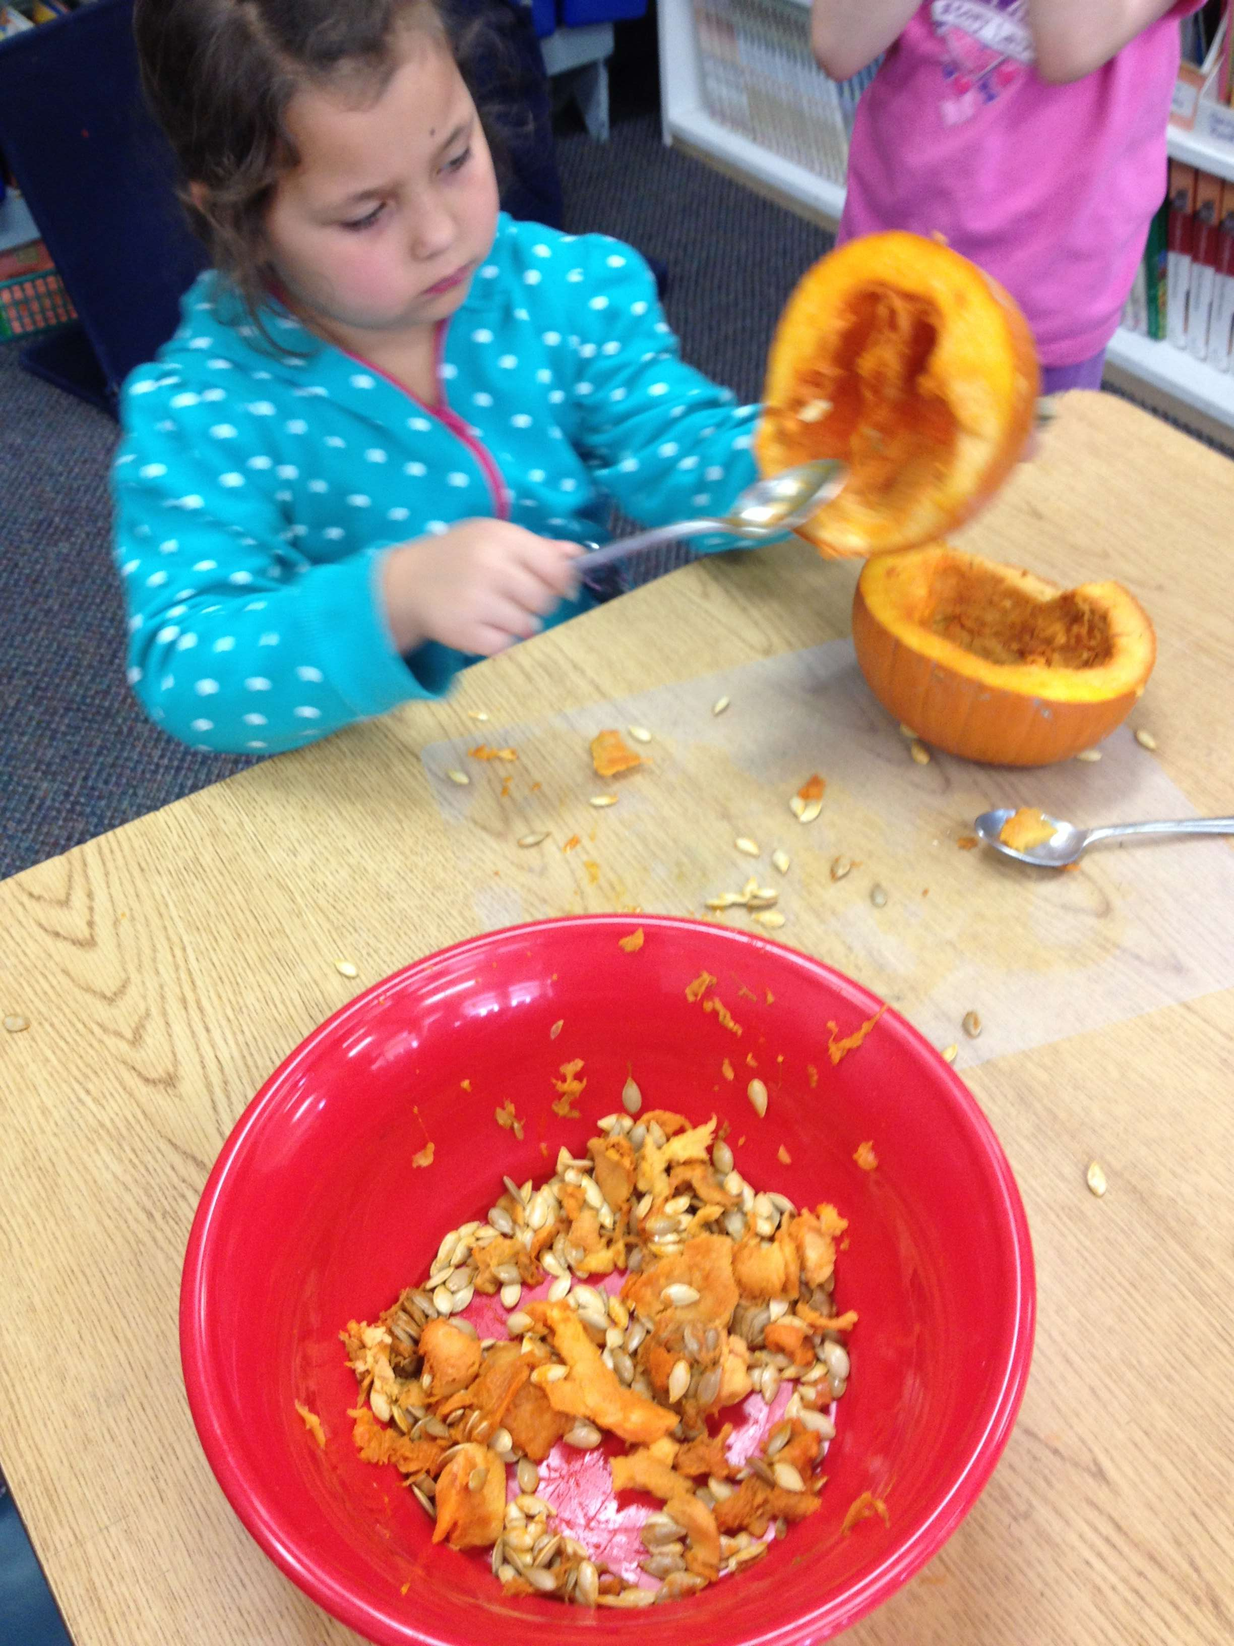
(Cupcake sized servings of pumpkin pie!)
DOUGH:
2 ½ c. pastry flour
1 tsp. salt
1 stick cold butter
1 c. ice water
DIRECTIONS:
In a food processor, pulse the dry ingredients until blended. Chop the butter into TB. Sizes and add to dry ingredients all at once. Pulse until consistency resembles corn meal.
Slowly pulse in the ice water (not the ice!) until you see the mixture begin to fall away from the sides of the processor. Open and check that the dough sticks together between your fingers. When it does, empty the processor onto a lightly floured surface and lightly knead together. Form two disks. Wrap in plastic wrap and refrigerate while you make the filling.

f
FILLING:
Team #1 (wet ingredients)
Mix in a medium sized bowl until blended:
2 cups cooked pumpkin
1 ½ cups evaporated milk or heavy cream
Team #2 (dry ingredients)
Mix in a small bowl:
¼ cup brown sugar
½ cup white sugar
½ tsp. salt
Team # 3 (eggs and spices)
Mix in a small bowl:
2 eggs
1 tsp. pumpkin pie spice (OR ½ tsp. ginger, ¼ tsp nutmeg, ¼ tsp cloves)

Add Team #2 and Team # 3 ingredients to the medium sized bowl (Team #1). And blend together well.

Remove pastry dough from wrapper and roll to 1/8 inch thickness on a floured surface, rolling from the center outward evenly.

Cut to fit cupcake rounds and gently place dough to fit. Use a fork to prick holes in the dough for even cooking. Pour enough filling in to fill 3/4 full.

Bake 15 minutes at 425 degrees. Then reduce heat to 350 and bake until a knife inserted into the filling come out clean (30 to 45 minutes).

Remove from oven. Cool on a rack. Enjoy or freeze for another day.

Name___________________ Team#____________________________

Pumpkin Tarts

My team’s job was: (Draw and write about how you helped make the tarts.)

The ingredients I measured were:_____________________________________________

________________________________________________________________________.

What I wonder about making the pumpkin tarts is________________________________

